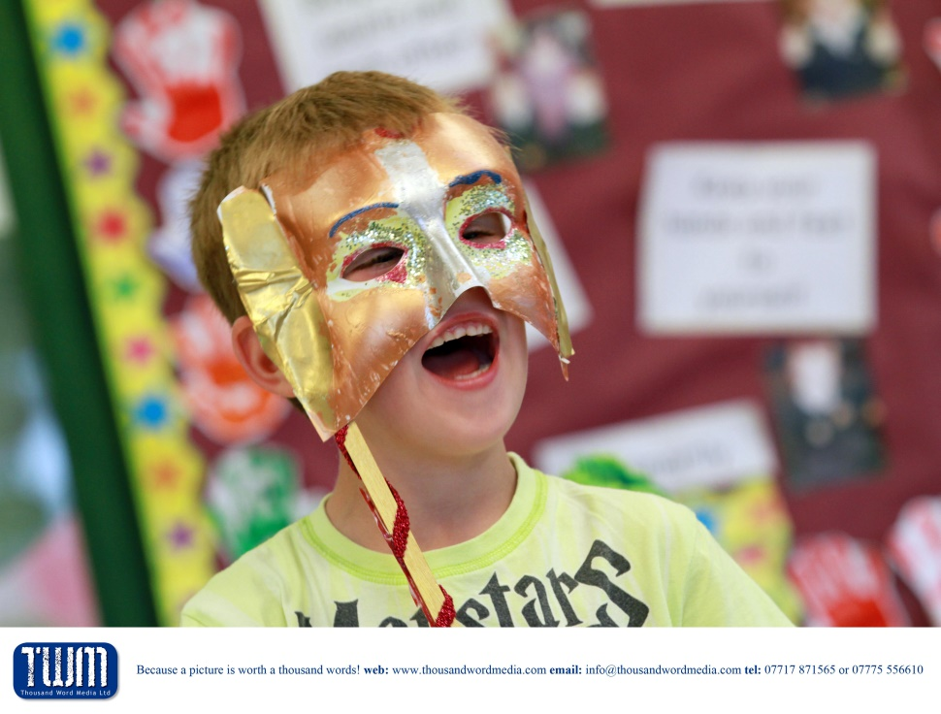

Teaching Assistant

Recruitment Pack

Coaley CofE Primary Academy

Dear Applicant,

Thank you for your interest in the post of Teaching Assistant.

Coaley CofE Primary Academy is part of a wider family of schools. Originally established in 2012 as one of the first Diocesan Multi-Academy Trusts, The Diocese of Gloucester Academies Trust is now recognised as a successful and growing Trust. There are currently 24 primary schools within the Trust family, including 22 church schools and two community schools.

I hope the information enclosed in this pack, along with the job description and person specification will provide you with a helpful context for this role. You may also find our school website [Coaley Church of England Primary Academy - Home](https://www.coaleyacademy.co.uk/web/) and the Trust website - [www.dgat.org.uk](http://www.dgat.org.uk) - useful sources of information.

If you would like an informal chat to inform your decision about applying for the role I would be pleased to hear from you. I’m sure you will find that we have much to offer. Details of how to contact me can be found on page three of this pack.

The closing date for completed applications is **Friday 11th July by 3pm**. Interviews are scheduled to take place on **Wednesday 16th July.**

To submit your application please email the completed form to [admin@coaley.dgat.org.uk](mailto:admin@coaley.dgat.org.uk), Mrs Sian King before the closing date.

Yours faithfully

Jen Thomas

Headteacher

The Diocese of Gloucester Academies Trust seek to appoint an

**Teaching Assistant**

Coaley CofE Primary Academy is a small school set in an idyllic village. We are proud members of the DGAT family. We are an ambitious and growing school with currently 79 pupils on roll, within 3 mixed classes.

We are seeking to appoint a part-time SEND Teaching Assistant to support the learning of pupils with EHCPs.

The role will involve working either to implement bespoke interventions, facilitate small group work or supporting the children in a whole class setting. Interventions will be associated with improving literacy and numeracy understanding, supporting behaviour, developing social and emotional skills and developing independent learning skills.

Key Requirements:

* Experience working with children with special educational needs
* Ability to deliver personalised and engaging curriculum, under the guidance of class teacher and SENDCo
* Strong interpersonal skills and a caring attitude
* High level of commitment and initiative

Why join Coaley Family?

* A supportive and inclusive working environment
* Excellent opportunities for personal and professional development
* Fantastic children who are eager to learn
* A family community

The post is offered as a salary of Grade 3 point 4 on a fixed term basis.

This is a part-time post for 21 hours a week.

Further details and an application form can be downloaded from the vacancy area of our website [Coaley Church of England Primary Academy - Vacancies](https://www.coaleyacademy.co.uk/web/vacancies/672282).

If you would like an informal conversation about the role please contact Jen Thomas, initially by email at [head@coaley.dgat.org.uk](mailto:head@coaley.dgat.org.uk)

Closing date for applications is **Friday 11th July by 3pm**

**Other information that might help you decide if this is the role for you**

|  |  |
| --- | --- |
| Usual working days and times:  There is some flexibility but hours are to be predominantly the afternoons.  Hours may look like this: | Mon- 11.00-3.15  Tues- 11.00-3.15  Weds- 11.00-3.15  Thurs-  11.00-3.15  Fri -  11.00 -3.00 |
| Work environment | Classroom |
| Dress code: | Smart |
| Employee benefits: | Free and confidential employee assistance programme available 24/7  High quality professional development – please see the DGAT Continuous Professional Development and Learning Brochure for more information here: <https://www.dgat.org.uk/cpdl-and-events>  A range of clear and supportive policies.  An annual wellbeing survey and access to an online wellbeing toolkit. |

Please note:

The Diocese of Gloucester Academies Trust is committed to safeguarding and promoting the welfare of children and young people and expects all staff to share this commitment. An enhanced DBS check is required for the successful candidate.The Trust also requires consent from applicants to carry out online searches of publicly available information, including social media, prior to interview.

All posts are subject to satisfactory references.

**Background Information**

The Diocese of Gloucester Academies Trust (DGAT) is a Multi-Academy Trust established by the Diocesan Board of Education (DBE) in 2012 to serve schools from across the County. There are currently twenty-one primary, one junior and two infant schools within the Trust. Twenty-two of the schools have Church of England designation.

The Trust is happy to work with schools that are exploring academy conversion and intends to continue to welcome more schools to our family.

***Our vision is to enable all to flourish.***

Our vision is rooted in our Christian foundation and our belief that all within our family should experience life in all its fullness.

**Our aims are to be:**

* Authentically Christian
* Boldly passionate about excellence in learning
* Relentlessly driven in our aspiration for everyone

​

**Our core principles:**

* We aspire to be the best we can be in an ever-changing environment - providing opportunities for all to flourish
* Within our DGAT family we cherish everyone as individuals; appreciating and celebrating diversity
* We act with integrity; we are open to challenge and we are reflective about our practice
* We treat everyone with dignity and respect
* Through collaboration, in a nurturing community, we grow, learn and achieve

***School is Trust and Trust is School***

In order to support our family of schools, DGAT provides the following support:

* School Improvement
* Christian Character
* HR and Legal
* Finance and Business
* Premises and Insurance
* Compliance and GDPR
* Governance

**Job Description**

|  |  |
| --- | --- |
| Job Title: | Teaching Assistant |
| Responsible to: | SENDCO/Class teacher |
| Line Management: | Headteacher |
| Contract Type: | Fixed term |

**Overall purpose of this post**

To work under the instruction/guidance of teaching/senior staff to support the children’s educational development.

**Other**

The current main duties and responsibilities of this post are outlined in this job description. The list is not intended to be exhaustive. The need for flexibility, shared accountability and team working is required. The post-holder is expected to carry out any other related duties that are within their skills and abilities, commensurate with the post’s banding and whenever reasonably instructed.

Diversity, equity, and inclusion are at the core of who we are. Our commitment to these values is central to our vision and to our impact. We know that having varied perspectives that are representative of the communities we serve helps generate better ideas to solve the complex problems of a changing and increasingly diverse world.

It is the practice of the Diocese of Gloucester Academies Trust to review job descriptions annually to ensure that they relate to the role as then being performed or to incorporate whatever reasonable changes that have occurred over time or are being proposed. This review will be carried out by the Trust in consultation with the post-holder before any changes are implemented. The post-holder is expected to participate fully in such discussions and implementation.

**Person Specification**

|  |  |  |
| --- | --- | --- |
|  | **Essential** | **Desirable** |
| **Personal Values** | | |
| Committed to actively promoting the Christian ethos and values of the school | **x** |  |
| Committed to the school’s vision | **x** |  |
| **Qualifications** | | |
| Basic skills in English and Maths, GCSE or equivalent | **X** |  |
| NVQ or equivalent childcare qualification, ICT skills |  | **X** |
| Commitment to continuing own professional development. | **X** |  |
| **Experience** | | |
| Knowledge of primary aged children |  | **X** |
| Knowledge of the primary curriculum |  | **X** |
| Experience of KS1 and KS2 |  | **X** |
| Previous SEND experience |  | **X** |
| Good experience of inclusion and supporting the learning of children with a variety of needs. |  | **X** |
| **Personal qualities** | | |
| Good written and oral skills | **X** |  |
| Well-motivated with the ability to use own initiative | **X** |  |

|  |  |  |
| --- | --- | --- |
| Excellent organisational skills and attention to detail | **X** |  |
| Able to work within a team | **X** |  |
| Reliable and punctual | **X** |  |
| Able to work efficiently and accurately under pressure and to prioritise tasks | **X** |  |
| Confident in dealing with a variety of stakeholders | **X** |  |
| Professional and honest | **X** |  |
| Ability to inspire and nurture children. | **X** |  |
| Ability to work flexibly and collaboratively within a team and know when to seek the advice and support of colleagues. | **X** |  |
| **Safeguarding (Training will be given)** | | |
| Secure awareness of child protection procedures. |  | **X** |
| Commitment to promoting the welfare of all children. | **X** |  |